**Dataset :** CASIA V2 is a dataset for forgery classification. It contains 4795 images, 1701 authentic and 3274 forged.

**Detect Copy-Move Image Forgery Model details:**

Convolutional neural network (CNN) architecture is proposed for the effective detection of copy-move image forgery. The proposed architecture is computationally lightweight with a suitable number of convolutional and max-pooling layers.

CNN includes many layers: convolutional layer, maxpooling layer, flattening layer, and full connection layer.

* The convolutional layer: is the activation function, and it is a non-linear function. It has several types;  
  the activation function is most commonly used. It is a non-linear function with several types, as shown in  
  The most commonly used them are:   
  + ReLU (rectified linear unit) Its importance is reducing the number of accounts performed.
  + Sigmoid, which is used in the output layer.
* B. Max-pooling layer: It collects the features extracted from the image, reduces the dimensions, and extracts the most important features present in the image.
* **Flattening layer:** it converts the characteristics taken from max-pooling into a one-dimensional matrix
* **Fully connected layer:** it puts all the neurons together.

The input image is resized to enter the next stage without cropping any image parts in the preprocessing data stage. The feature extraction stage contains three convolution layers, followed by a max-pooling layer. At the end of this stage, a full connection layer connects all features with the dense layer. Finally, the classification stage is called to classify the data into two classifications (forged or original). The convolution layers as feature mining, in which each convolution layer generates its feature maps using its own set of filters (i.e., ReLU). The feature maps produced from the first convolution layer are used in the next max-pooling layer to produce resized pooled feature maps, considered the inputs of the next convolution layer. The last feature maps merged with the final max-pooling are formatted as vectors and incorporated into Fully Connected.

**Training Model Graphs Acc, Loss**

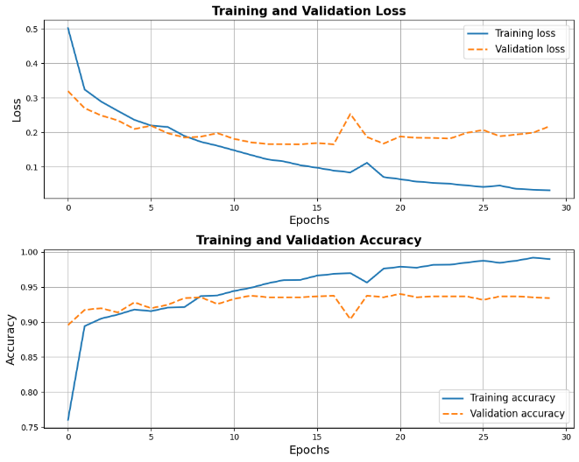

**Training Model Graphs Precision, Recall, F1-Score**

**ROC**

**Confusion Matrix for the Test Data**

